

CANCER INCIDENCE IN UNITED ARAB EMIRATES ANNUAL REPORT OF THE UAE - NATIONAL CANCER REGISTRY - 2019

Statistics and Research Center

www.mohap.gov.ae

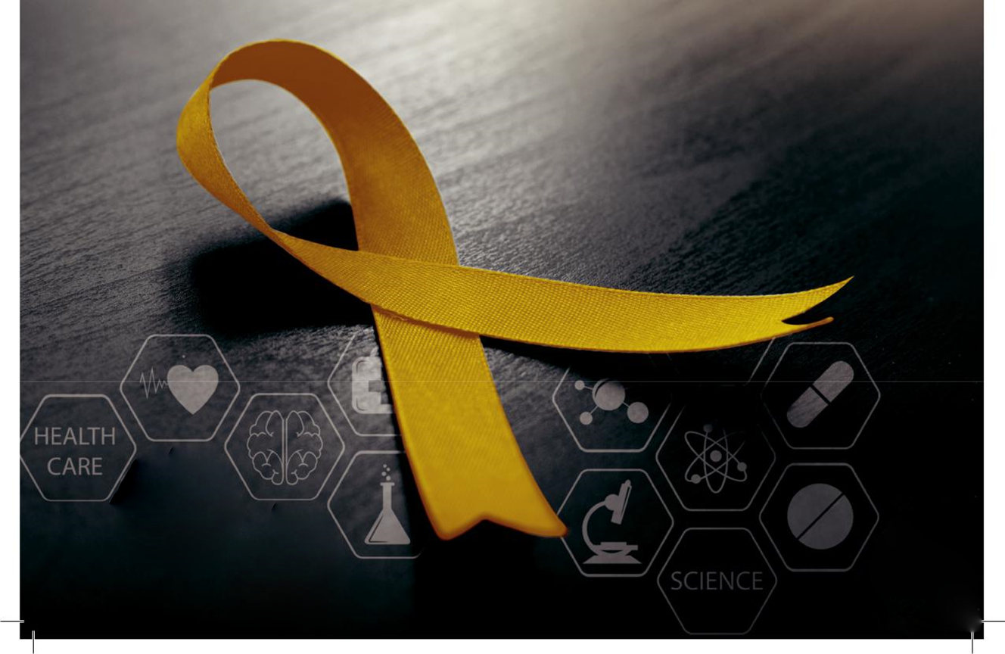

WORD FROM THE DIRECTOR OF THE

STATISTICS AND RESEARCH CENTER

I’m delighted to present the annual report of UAE national cancer registry 2019, which is a collaborative effort by the team of UAE National Cancer Registry (UAE-NCR) and all stakeholders, healthcare providers. (UAE-NCR) is a population-based Cancer Registry with epidemiological and public health aspects in mind, and has always remained the corner stone of National Cancer Program particularly from the public health point of view. UAE-NCR is the only source which provides authentic data on incidence and mortality of cancer in various parts of the nation.

The availability of data on continuous basis has a special importance as uniformly collected long term data helps in understanding the trends in cancer occurrence in our country. The annual cancer registries make this continuous data available for research and evaluation of cancer control efforts to effectively confront the disease. Countrywide figures on the incidence of cancer are published online, while experts and academics will have access to more detailed data on request.

This consolidated report is the 6th annual report of UAE-NCR since the establishment of the UAE
National Diseases Registry. It provides insight into the data collected from all healthcare providers across UAE for year 2019.

We are certain that this will help the decision makers in Healthcare of our great nation to understand the burden of cancer and shall execute measures to keep it under control.

The international comparison of cancer rates with the UAE-NCR and cancer trends for the data collected from three oldest UAE-NCR reports would be of interest for all readers, the data will also allow UAE cancer patterns to be compared with those of other countries, through organizations such as the International Agency for Cancer Research at the World Health Organization.

The staff working in the UAE-NCR have put in a lot of hard work to collect, abstract, verify and made good efforts to ensure that the data reported is of international standards.
Many thanks to the UAE National Cancer Registry team in Ministry of Health & Prevention for their great efforts, and also many thanks to all stakeholders and healthcare providers who shared the success of this endeavor.
Looking forward to see forthcoming reports in this series and reports on an annual basis related to trends, and developments in treatment of cancer.

Dr. Alya Zaid Mohammed Harbi

Director of Statistics and Research Center

EXECUTIVE SUMMARY

This is the 6th annual report of the UAE National Cancer Registry. This report summarizes cancer incidence and mortality in United Arab Emiratis for the period 2019.

Between 1st January – 31st December 2019, the total number of newly diagnosed cancer cases (malignant & in-situ) reported to the UAE National Cancer Registry (UAE-NCR) was 4633. Of which 4381 (94.56%) were malignant and 252 (5.44%) were In-situ cases. Overall cancer was more among women than men; it affected 2604 (56.2%) females and 2029 (43.8%) males.
Among UAE citizens, a total number of 1193 cases were newly diagnosed with cancer; out of which 1117 (93.6%) cases were malignant and 76 (6.4 %) were in-situ cases. Similarly, in Non-UAE citizens, 3440 cases were newly diagnosed with cancer, 3264 (94.9%) cases were malignant and 176 (5.1 %) were in-situ cases

Representing an overall crude incidence rate of 46.1/100,000 for both genders. Figures showed a clear female predominance for cancer incidence. The crude incidence rate was higher for females 75.8/100,000 than for males 31.0/100,000.

The overall age-standardized incidence rate (ASR) was 78.4/100,000.

Breast, thyroid, colorectal, skin and leukemia were the top ranked cancers among all new cancer cases in both genders (Table 2). Colorectal, skin, prostate and leukemia and Non-Hodgkin lymphoma were the top ranked cancers among the males (Table 3).
Among females, breast, thyroid, colorectal, uterus and ovary were the top ranked cancers (Table 3).

In the year of 2019, there were 125 children at the age group of 0-14 years diagnosed with new cancer in UAE (54 % were females and 46 % were males). This constitutes about (2.9%) of all registered malignant cases.

Leukemia, brain & CNS, connective and soft tissue, Non-Hodgkin lymphoma, and bone and articular were the most common cancers in boys and girls, Table 4.

The third leading cause of death in UAE after diseases of the circulatory system and injuries was found to be cancer.
The number of deaths from cancer totaled 1181 (629 in males, 552 in females) and accounted for 13.11% of all deaths regardless of nationality, type of cancer or gender, Figure 5.

This represents an estimated age-standardized mortality rate of 33.3 deaths per 100,000 for both genders.

Breast cancer was the leading cause of cancer death in 2019, with an estimated average of 11.6% of cancer deaths per year, colon cancer was the second most common cause of cancer death in both sexes, lung cancer was the third common cause of cancer death in both sexes, (Table 5).



CHAPTER

1

ANNUAL REPORT OF THE UAE- NATIONAL CANCER REGISTRY

INTRODUCTION
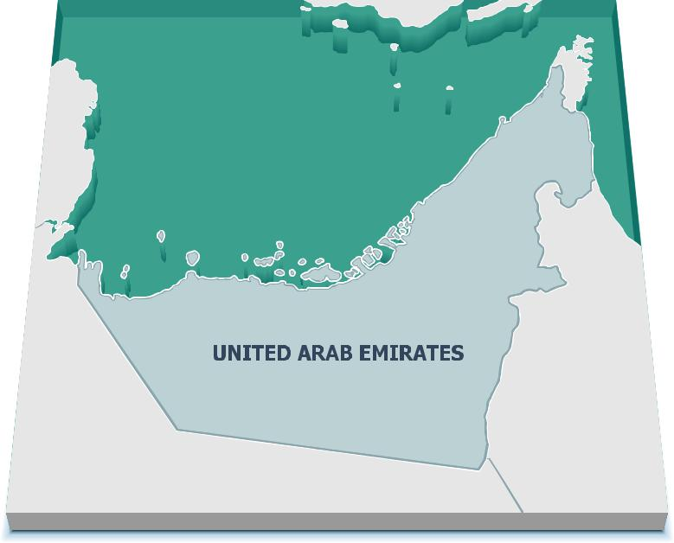

UAE Geography

The United Arab Emirates (UAE) was formed as a constitutional federation of seven emirates: Abu Dhabi, Dubai, Sharjah, Ajman, Umm Al Quwain, Ras Al Khaimah and Fujairah, which came together as one state on 2nd December 1971 under the former president, His Highness the late Sheikh Zayed bin Sultan Al Nahyan. Through exploitation of the UAE’s abundant oil and natural gas resources starting in the 1960s, the country has been transformed from a tribal society reliant on agriculture and fishing to a significant and respected supplier in global energy markets as well as an important member of the international community [5].

During this period, the UAE has forged a distinct national identity and enjoyed a high degree of political stability. The UAE is located at the tip of the Arabian Peninsula with coastlines on the Gulf of Oman and the Arabian Gulf. It lies between Oman and Saudi Arabia, and is a strategic location along the Strait of Hormuz, a vital transit point

for the world’s crude oil [5]. According to the National Bureau of Statistics (NBS), the UAE’s total land area is 71,023.6 square kilometers (km2). The Emirate of Abu Dhabi accounts for 59,435 km2 , 83.7% of the total land area, while the smallest emirate, Ajman, encompasses only 0.4% of it, 268 km2[5].

Four-fifth of the UAE is desert but has contrasting landscapes - from the towering red dunes of the Liwa to the rich palm-filled Oasis of Al Ain, from the precipitous Hajjar Mountains to the more fertile stretches of its coastal plains. The UAE has become an important player in regional and international affairs [6]. In 1971, the late President Sheikh Zayed bin Sultan Al Nahyan unified the small, underdeveloped states into a federation, the only one in the Arab world. With his visionary leadership, oil wealth was used to develop the UAE into one of the world’s most open and successful economies. In 2004, His Highness Sheikh Khalifa bin Zayed Al Nahyan became the President and has since continued to strive towards an ambitious vision for the UAE [6].

Location

Bordered to the North by the Arabian Gulf, to the East by the Gulf of Oman and Sultanate of Oman, to the South by Saudi Arabia and Sultanate of Oman and to the West by Qatar and Saudi Arabia.

UAE National Cancer Registry is the population-based cancer registry for the United Arab Emirates established under the jurisdiction of the Ministry of Health and Prevention (MOHAP) by the order of UAE Cabinet and His Excellency the Minister of Health and Prevention.

UAE National Cancer Registry systematically collects, stores, summarizes, analyses and distributes information about cancer patients who are diagnosed and/or treated in UAE. It provides information on cancer patterns and trends over time as well as monitors cancer incidence in UAE. The Cancer Registry is a part of the National Diseases Registry and it comes under the auspices of the Statistics and Research Center. UAE National Cancer Registry will produce a report about the cancer incidence on an annual basis, and as incidence data are accumulated over the years, the registry will eventually be able to produce certain trends which would help in studying the distribution of such conditions in different regions of the country.

Goals

The primary goal of the UAE National Cancer Registry was to determine the national cancer statistics in UAE, to provide decision makers and researchers with reliable data, to monitor cancer screening and early detection programs, and to plan for cancer services and cancer control.
Cancer registry

Cancer registration is a vital and essential tool in cancer control. A cancer registry has been defined as an organization for the storage, collection, analysis, and interpretation of data on individuals with cancer. A population-based cancer registry gathers the data from numerous healthcare providers in a defined geographic area and can serve to demonstrate incidence trends for cancer of different sites over time or between population subdivisions. It can offer data to assess the effects of different types of treatment over time and to assess the effects of early detection programs, such as colorectal screening or mammography. Cancer registry data can be used for epidemiologic studies to identify causes of cancer. It can be useful in identifying unusual clusters of cancer cases [8]. Information on the mortality as well as incidence of cancers, in addition to their changing trends, is an important element in the planning and monitoring of programs for early detection, cancer prevention, and treatment [9].

UAE national cancer registry

MOHAP aims to establish unified accurate national diseases registries. MOHAP has established the National Diseases Registries to enable the diseases registries to access medical information while safeguarding data confidentiality.

Methods

The UAE National Cancer Registry (UAE-NCR) records demographic, cancer, staging, clinical, and treatment information for all cancers diagnosed in UAE in accordance with internationally accepted registration and coding standards. For UAE and Non-UAE citizens all malignant and in-situ cases diagnosed in UAE during 1st Jan. – 31st Dec. 2019 were notified and registered to UAE national cancer registry.

There are two methods of data collection:

Active method

Data was collected and abstracted by registry staff through regular visits to medical treatment abroad department at MOHAP.

Passive method

The focal points from stakeholder and healthcare providers across UAE, collect cancer data from patient’s files, HIMS (Health information management system), and pathology reports, complete a standardized form and submit it to the UAE National Cancer Registry.

Mortality data of Abu Dhabi was provided by the department of health – Abu Dhabi and mortality data of other Emirates was provided by MOHAP.

Incidence and mortality rates were calculated by using total UAE Resident Population as estimated by Federal Competitiveness and Statistics Center (FCSC)

Source of data and data processing
The registry collects data on malignant neoplasms according to the recommendations of the International Agency for Research on Cancer (IARC) from a combination of sources, such as:

- DOH central cancer registry: highly qualified central based cancer registry in DOH, this registry acts as a central one covering all cancer data in Abu Dhabi.

- DHA central cancer registry: highly qualified central based cancer registry in DHA

- Hospital admissions and medical records departments from all public, private, and university hospitals all over UAE through international classification of disease ICD-10 CM and ICD-O-3

- Notifications by the medical profession

- Reports from the pathology laboratories

- Mortality data

- Medical treatment abroad

All data supplied for this report were coded to ICD-10 CM and ICD-O-3 and then were converted to ICD-10 CM for analysis and report writing to ensure data comparability, all cases notified to the UAE-NCR must follow the IARC rules.
All relevant information of new cases would be checked for possible duplication against a master index. The clinical data would then be verified by CTR staff.
Registered cases of carcinoma in-situ were excluded in the computation of crude incidence rates. All the results refer to the resident population (UAE citizens and Non-UAE citizens).
The data is used for monitoring the trends in incidence, research, planning, and evaluation of the cancer care facilities.

ANNUAL REPORT OF THE UAE- NATIONAL CANCER REGISTRY

Information presented in this report are based on the cancer data collected about patients newly diagnosed during January 1 to December 31, 2019 in UAE.

Reportable list

All cases with a behavior code 2 and 3 of the International Classification of Diseases for Oncology, third Edition (ICD-O-3), malignant and in-situ cases of the ICD-10 CM were included in the registry.

Data management

A ministerial decree has categorized cancer as a mandatory notifiable disease. This ensures the opportunity for comprehensive data collection. The UAE-NCR strives for full access to cancer data from all MOHAP and other governmental and private hospitals, as well as clinics and laboratories throughout the UAE.
Every item relating to the patient were collated and updated. The registry registered all new cases of cancer diagnosed in UAE. Multiple sources of data had assisted in optimizing completeness of collection; however, this could create problem of multiple notification of a patient. This issue was addressed by cross checking Emirates ID number, names, age, gender, date of birth and address, which is a good quality indicator and shows good coverage and completeness of cancer cases in UAE. Emirates identification card number is a unique number given to each UAE citizen and Non-UAE citizen.
After checking and filtering cancer data received, we updated the data and excluded any duplicate and already registered cases.
Every effort was made to ensure that all the variables were completed. In the event if there was incomplete information, the notification forms with incomplete information were sent back to the respective data providers for further clarification and returned back to the registry upon completion.
All updated information collected on softcopies, either passively or actively, were entered into the computer database. Electronic data maintained in the cancer registry databases were subjected to on-going quality control.

The UAE population used to calculate rates

In this report, we have used the UAE Resident Population to compute the crude and age standardized incidence rates, and mortality rates in order to describe various indicators where ‘rates’ were calculated.

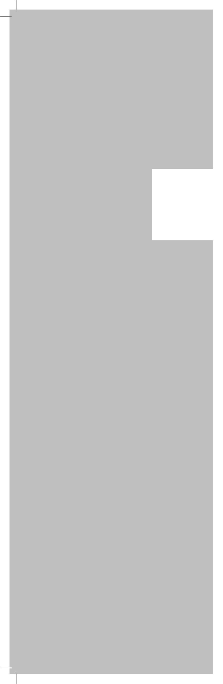

CHAPTER

2

OVERALL CANCER INCIDENT CASES

The incidence and mortality rates are essential epidemiological measures to quantify the pattern of cancer occurrence in a specific society, and in different sub-groups of the population. These cancer rates can be used for predicting the occurrence of cancers and their future magnitude and also in estimating the future demands for treatment, diagnosis and prevention of cancers across the community. The natural data source on the cancer occurrence has long been considered to be a hospital based, where majority of the cancer patients are offered treatments.

In the 6th annual report for the year 2019, we have presented the number of new cancer cases among UAE citizens and Non-UAE citizens, who were diagnosed and / or treated in UAE. Malignant and in-situ behaviors are reportable to UAE-NCR, while benign and borderline malignancies are not reportable in this registry in the year 2019.

Cancer Incidence (malignant & in-situ) in UAE, 2019

Between 1st January – 31st December 2019, the total number of newly diagnosed cancer cases (malignant & in-situ) reported to the UAE National Cancer Registry (UAE-NCR) was 4633. Of which 4381 (94.56%) were malignant and 252 (5.44%) were In-situ cases. Overall cancer was more among women than men; it affected 2604 (56.2%) females and 2029 (43.8%) males.
Among UAE citizens, a total number of 1193 cases were newly diagnosed with cancer; out of which 1117 (93.6%) cases were malignant and 76 (6.4 %) were in-situ cases. Similarly, in Non-UAE citizens, 3440 cases were newly diagnosed with cancer, 3264 (94.9%) cases were malignant and 176 (5.1 %) were in-situ cases.

Table 1 represents the distribution of all types of cancer cases among UAE population (UAE and Non-UAE citizens) according to gender.

ANNUAL REPORT OF THE UAE- NATIONAL CANCER REGISTRY

Table 1: Number of cancer cases among UAE population according to primary site, gender, and nationality, 2019

Primary site ICD-10 | UAE Citizens |  |  | Non-UAE Citizens |  |  | Total
Primary site ICD-10 | Female | Male | Total | Female | Male | Total | Total
(C00-C96) All invasive cancers (Malignant Cases) | 674 | 443 | 1117 | 1751 | 1513 | 3264 | 4381
C00-C14 Lip, Oral cavity & pharynx | 11 | 20 | 31 | 28 | 83 | 111 | 142
C15 Esophagus | 2 | 3 | 5 | 5 | 18 | 23 | 28
C16 Stomach | 9 | 20 | 29 | 15 | 45 | 60 | 89
C17 Small intestine | 2 | 3 | 5 | 8 | 11 | 19 | 24
C18-C21 Colorectal | 63 | 66 | 129 | 94 | 190 | 284 | 413
C22 Liver and intrahepatic bile ducts | 9 | 17 | 26 | 10 | 36 | 46 | 72
C23, C24 Gallbladder, other and unspecified part of biliary tract | 5 | 5 | 10 | 8 | 13 | 21 | 31
C25 Pancreas | 4 | 10 | 14 | 13 | 28 | 41 | 55
C30, C31 Nasal cavity, middle ear, accessory sinuses |  | 1 | 1 | 4 | 4 | 8 | 9
C32 Larynx |  | 11 | 11 |  | 20 | 20 | 31
C34 Bronchus and Lung | 10 | 31 | 41 | 37 | 73 | 110 | 151
C40-C41 Bone and articular cartilage | 2 | 5 | 7 | 9 | 13 | 22 | 29
C43 Skin melanoma | 1 | 2 | 3 | 22 | 26 | 48 | 51
C44 Skin | 7 | 12 | 19 | 90 | 169 | 259 | 278
C45 Mesothelioma | 1 |  | 1 | 3 | 4 | 7 | 8
C46 Kaposi sarcoma |  |  |  |  | 2 | 2 | 2
C48 Retroperitoneum and peritoneum | 1 |  | 1 | 8 | 2 | 10 | 11
C49 Connective and soft tissue | 5 | 3 | 8 | 15 | 15 | 30 | 38
C50 Breast | 209 | 1 | 210 | 666 | 7 | 673 | 883
C53 Cervix uteri | 22 |  | 22 | 68 |  | 68 | 90
C54-C55 Uterus | 46 |  | 46 | 79 |  | 79 | 125
C56 Ovary | 24 |  | 24 | 76 |  | 76 | 100
C61 Prostate |  | 57 | 57 |  | 115 | 115 | 172
C62 Testis |  | 8 | 8 |  | 31 | 31 | 39
C64-C65 Kidney & Renal pelvis | 9 | 20 | 29 | 24 | 63 | 87 | 116
C66, C68 Ureter and other urinary organs |  | 3 | 3 |  | 2 | 2 | 5
C67 Urinary bladder | 7 | 20 | 27 | 10 | 73 | 83 | 110
C69 Eye | 1 | 2 | 3 | 1 | 4 | 5 | 8
C70-C72 Brain & CNS | 6 | 10 | 16 | 28 | 48 | 76 | 92
C73 Thyroid | 119 | 26 | 145 | 256 | 100 | 356 | 501
C74-C75 Other endocrine glands | 2 |  | 2 | 2 | 8 | 10 | 12
C76-C80 Unknown or unspecified sites | 9 | 4 | 13 | 15 | 29 | 44 | 57
C81 Hodgkin's lymphoma | 15 | 10 | 25 | 25 | 26 | 51 | 76
C82-C85, C96 Non-Hodgkin lymphoma | 32 | 32 | 64 | 52 | 99 | 151 | 215
C88, C90 Multiple myeloma | 5 | 5 | 10 | 10 | 22 | 32 | 42
C91-C95 Leukemia | 27 | 25 | 52 | 55 | 113 | 168 | 220
Other hematopoietic malignancies | 3 | 3 | 6 | 6 | 9 | 15 | 21
Other malignancies | 6 | 8 | 14 | 9 | 12 | 21 | 35
(D00-D09) Non-invasive cancers (In-Situ Cases) | 54 | 22 | 76 | 125 | 51 | 176 | 252
D00 Carcinoma in situ of oral cavity, oesophagus and stomach |  | 1 | 1 |  | 4 | 4 | 5
D01 Carcinoma in situ of other and unspecified digestive organs | 3 | 1 | 4 | 2 | 2 | 4 | 8
D02 Carcinoma in situ of middle are and respiratory system |  | 2 | 2 | 1 | 3 | 4 | 6
D03 Melanoma in situ |  | 1 | 1 | 8 | 12 | 20 | 21
D04 Carcinoma in situ of skin |  | 2 | 2 | 5 | 7 | 12 | 14
D05 Carcinoma in situ of breast | 24 | 1 | 25 | 68 | 2 | 70 | 95
D06 Carcinoma in situ of cervix uteri | 24 |  | 24 | 36 |  | 36 | 60
D07 Carcinoma in situ of other and unspecified genital organs |  |  |  | 1 | 4 | 5 | 5
D09 Carcinoma in situ of other and unspecified sites | 3 | 14 | 17 | 4 | 17 | 21 | 38
Grand Total | 728 | 465 | 1193 | 1876 | 1564 | 3440 | 4633

Figure 1: Distribution of cancer cases among UAE population by type of tumor, 2019

Figure 1 demonstrates the distribution of cancer cases among UAE population by the type of tumor in 2019, with 94.56% of malignant cases and 5.44% of the in-situ cases.

ANNUAL REPORT OF THE UAE- NATIONAL CANCER REGISTRY

Table 2: Top ten most common malignant primary sites among UAE population, 2019

Primary site ICD-10 | Number of malignant cases 2019 | %
C50 Breast | 883 | 20.2%
C73 Thyroid | 501 | 11.4%
C18-C21 Colorectal | 413 | 9.4%
C44 Skin | 278 | 6.3%
C91-C95 Leukemia | 220 | 5.0%
C82-C85, C96 Non-Hodgkin lymphoma | 215 | 4.9%
C61 Prostate | 172 | 3.9%
C34 Bronchus and Lung | 151 | 3.4%
C00-C14 Lip, Oral cavity & pharynx | 142 | 3.2%
C54-C55 Uterus | 125 | 2.9%

Between January and December 2019, the total number of breast cancer cases reported to the UAE National Cancer Registry among UAE population was 883, representing 20.2% of all malignant cases in 2019. Table 2 demonstrates the 10 most common cancers among the UAE population. The five most common cancers among UAE population in both genders are breast, thyroid, colorectal, skin and leukemia.

Table 3: Top ten most common malignant primary sites among Females & Males, 2019




Primary site ICD-10 | % |  | Primary site ICD-10 | %
C50 Breast | 36.1% |  | C18-C21 Colorectal | 13.1%
C73 Thyroid | 15.5% |  | C44 Skin | 9.3%
C18-C21 Colorectal | 6.5% |  | C61 Prostate | 8.8%
C54-C55 Uterus | 5.2% |  | C91-C95 Leukemia | 7.1%
C56 Ovary | 4.1% |  | C82-C85, C96 Non-Hodgkin lymphoma | 6.7%
C44 Skin | 4.0% |  | C73 Thyroid | 6.4%
C53 Cervix uteri | 3.7% |  | C34 Bronchus and Lung | 5.3%
C82-C85, C96 Non-Hodgkin lymphoma | 3.5% |  | C00-C14 Lip, Oral cavity & pharynx | 5.3%
C91-C95 Leukemia | 3.4% |  | C67 Urinary bladder | 4.8%
C34 Bronchus and Lung | 1.9% |  | C64-C65 Kidney & Renal pelvis | 4.2%

Breast cancer in females and colorectal cancer in males have shown the fastest increase in incidence over the past decade across UAE. The incidence of breast, thyroid, and colorectal cancers in females and colorectal, skin, prostate and leukemia in males has also been observed to increase markedly in 2019, Table 3.

Figure 2: Age group distribution of malignant cases in UAE, All gender, 2019

Figure 2 shows and summarizes the distribution of malignant cases by age group in UAE for the year 2019. The (40-44) year age group reached its highest peak showing highest frequency of cancer, but in contrast, malignant cases occurred relatively less frequently at (5-9) year age group.

CHAPTER

3

PEDIATRIC
MALIGNANCIES IN UAE

Until now cancer is the second prominent cause of death (following accidents) in children aged 5 to 14 years.
Incidence of pediatric cancers differ worldwide representing between 0.5% and 4.6% of all cancers. Overall incidence rates fluctuate between 50 and 200 per million children across the world [19].

Pediatric Malignancies in UAE, 2019
In the year of 2019, there were 125 children at the age group of 0-14 years diagnosed with new cancer in UAE. This constitutes about (2.9%) of all registered malignant cases.

ANNUAL REPORT OF THE UAE- NATIONAL CANCER REGISTRY

Pediatric cancer cases by gender in UAE, 2019

Figure 3: Distribution by gender of new pediatric cancer cases in UAE, 2019

Figure 3 represents a total of 125 new pediatric cancer cases that were registered out of which 53.6 % were females and 46.4 % were males.

Distribution of pediatric cancer cases by age group in UAE, 2019

Figure 4: Distribution of pediatric cancer cases by age groups in UAE, 2019

Figure 4 shows the distribution by age group of 125 pediatric cancer cases in UAE in the year of 2019. The data indicates that the top most frequency of pediatric cancer cases was found among age group 0-4 year (63; 50.4%), followed by age group 10-14 year (38; 30.4%). It was noted that the smaller number of cancer cases in pediatric population were diagnosed in the age group of 5-9 year (24; 19.2%).

Top five pediatric cancers by primary sites among both genders in UAE, 2019

Table 4: Distribution of top five pediatric cancer cases by primary sites in UAE, 2019

Primary sites ICD-10 | Number of pediatric cancer cases | %
C91-C95 Leukemia | 44 | 35.2%
C70-C72 Brain & CNS | 14 | 11.2%
C49 Connective and soft tissue | 9 | 7.2%
C82-C85, C96 Non-Hodgkin lymphoma | 9 | 7.2%
C40-C41 Bone and articular cartilage | 7 | 5.6%

Table 4 demonstrates the distribution of top five pediatric cancer sites among both genders in UAE population in the year 2019. The data represents that most common occurring cancer was leukemia (35.2%) followed by brain & CNS (11.2%), Connective and soft tissue (7.2%), Non-Hodgkin lymphoma (7.2%) and Bone and articular cartilage (5.6%).

CHAPTER

4

ANNUAL REPORT OF THE UAE- NATIONAL CANCER REGISTRY

CANCER MORTALITY, 2019

Total Number of Deaths

Cancer mortality has been contributed as the third leading cause of death in the United Arab Emirates after diseases of the circulatory system and injuries [20]. In 2019, a total number of 9006 death cases were reported in UAE among both UAE citizens and Non-UAE citizens regardless of the gender.

The number of deaths from cancer totaled 1181 (629 in males, 552 in females) and accounted for 13.11% of all deaths regardless of nationality, type of cancer or gender. Figure 5

This represents an estimated age-standardized mortality rate of 33.3 deaths per 100,000 for both genders.

Figure 5: Percentage of reported cancer deaths among UAE population, 2019

Mortality according to the primary sites

Breast cancer was the leading cause of cancer death in 2019, with an estimated average of 11.6% of cancer deaths per year, colon cancer was the second most common cause of cancer death in both sexes, lung cancer was the third common cause of cancer death in both sexes, (Table 5).

Table 5: Distribution of malignant cancer deaths by type of cancer in UAE, 2019

Underlying cause of death | %
Malignant Neoplasm of Breast | 11.6%
Malignant Neoplasm of Colon | 8.9%
Malignant Neoplasm of Trachea, bronchus & Lung | 8.8%
Leukemia | 4.4%
Malignant Neoplasm of Stomach | 4.7%
Malignant Neoplasm of Cervix Uteri | 0.6%
Malignant Neoplasm of Rectum | 1.1%
Other Malignant Neoplasm | 59.9%
Grand Total | 100.0%

PREPARED BY

Wael Shelpai, CTR®
Certified Tumor Registrar

Expert, National Disease Registries

Statistics and Research Center

Ministry of Health and Prevention

